PHSMUN 2026
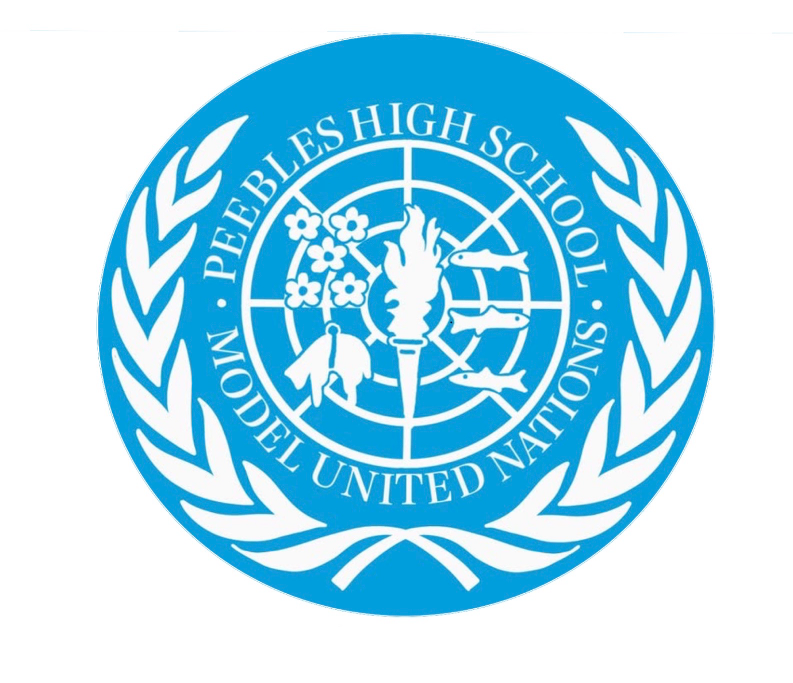

Arctic council topic 1: the issue of militarisation in the arctic
Chairs: Dawa Murray and Innes Reilly

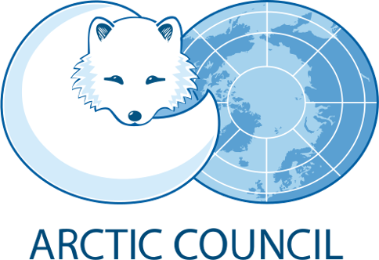
The Arctic is a strategically important region surrounding the North Pole. It consists of territory belonging to eight countries: Canada, Denmark (Greenland), Finland, Iceland, Norway, Russia, Sweden and the United States. These countries form the Arctic Council, which is your committee, established in 1996 to promote environmental protection and sustainable development. Climate change has increased the Arctic's geopolitical importance. Melting sea ice is creating greater access to shipping routes, natural resources and previously inaccessible territory. Consequently, countries are increasing their military presence to protect national security, economic interests and territorial claims.
Militarisation refers to the expansion of military forces, infrastructure and activity within a region. In the Arctic, this includes military bases, surveillance systems, naval activity and military exercises. Although countries often justify these developments as defensive, they have contributed to increasing geopolitical tensions.
There are a few main issues regarding the prospect of militarisation in the Arctic, below are the most relevant to this debate but we strongly recommend delegates conduct their own research on their own country's’ specific issues towards militarisation.
Russia and NATO Military Competition:
Russia possesses the largest share of Arctic territory and has significantly strengthened its military infrastructure in the region. NATO has also increased its military cooperation and exercises in the High North. Seven of the eight Arctic Council members are now NATO members. Russia views NATO's growing presence as a potential security threat, while NATO countries are concerned about Russian military expansion. This creates a security dilemma in which defensive actions by one side are perceived as threatening by another.
Competition over Natural Resources
The Arctic contains significant potential reserves of oil, natural gas and valuable minerals. Russia, the United States, Canada, Norway and Denmark (through Greenland) have economic interests in these resources. Competition over access, maritime boundaries and seabed rights could increase military tensions. Resource extraction also presents serious environmental risks to the fragile Arctic ecosystem.
Disputes over Shipping Routes
Melting sea ice is increasing access to two important shipping routes: Russia's Northern Sea Route and Canada's Northwest Passage. Russia wants to regulate shipping along its northern coastline, while other countries emphasise freedom of navigation. Canada considers the Northwest Passage its internal waters, whereas the United States argues that it should be treated as an international strait. These disagreements create potential diplomatic and security tensions.
China's Growing Arctic Interests
China is not an Arctic Council member and has no Arctic territory, but it describes itself as a 'near-Arctic state'. It seeks greater access to shipping routes, scientific research and natural resources. Its growing economic and strategic cooperation with Russia concerns the United States and NATO, who fear increasing Chinese influence in the region.
Environmental and Indigenous Concerns
Military expansion, shipping and resource extraction threaten Arctic wildlife and ecosystems through pollution and habitat disruption. Indigenous communities, including Inuit and Sámi peoples, may also experience disruption to their traditional livelihoods, land and resources. Their representation in decisions concerning Arctic development is therefore essential.
When considering the issue of militarisation in the arctic, it is essential that you are aware of the preexisting geopolitical tensions which will be relevant when debating this issue:
- Russia and the United States: Military competition, NATO expansion and strategic influence.
- Russia and Norway: Military activity and security concerns in the High North.
- Russia and Canada: Arctic sovereignty, shipping routes and military competition.
- United States and Canada: Disagreement over the legal status of the Northwest Passage.
- United States and Denmark: Greenland's strategic importance and territorial sovereignty.
- Russia and Finland: NATO expansion and increased military cooperation near Russian borders.
- Russia and Sweden: NATO membership and regional security concerns.
- United States and China: Competition over resources, shipping routes and geopolitical influence.
The Arctic Councils Place in international law and statutes:
The Arctic Council was established through the 1996 Ottawa Declaration. Its purpose is to encourage cooperation between Arctic states and Indigenous communities on environmental protection and sustainable development.
Importantly, the Council's mandate excludes military security. Therefore, it cannot directly regulate military activity or impose restrictions on countries' armed forces. This creates a significant challenge for delegates discussing militarisation.
Three important international frameworks are relevant:
- United Nations Convention on the Law of the Sea (UNCLOS): Establishes international rules concerning maritime boundaries, navigation and access to marine resources.
- Ottawa Declaration (1996): Established the Arctic Council and defined its responsibilities, excluding military security.
- United Nations Charter: Establishes principles of sovereignty, peaceful dispute resolution and restrictions on the use of force.
Relations between Russia and the other Arctic states deteriorated following Russia's 2022 invasion of Ukraine, resulting in the suspension of much Arctic Council cooperation involving Russia. This has weakened diplomatic trust and regional cooperation.
Recommended considerations for delegates:
Concerns:
The central challenge is balancing national security with international cooperation. Climate change, increased accessibility and competition over resources have transformed the Arctic into an increasingly important geopolitical region.
Russia–NATO tensions represent the most significant military concern, while China's growing influence adds another dimension to international competition. However, militarisation also raises concerns about environmental protection, Indigenous rights and maritime sovereignty.
Solutions:
Military transparency: Improve communication about military exercises and activities to reduce misunderstandings and accidental escalation.
Diplomatic cooperation: Maintain communication between Arctic states and restore cooperation where possible, including with Russia.
Environmental protection: Strengthen regulations concerning pollution, shipping and resource extraction.
Indigenous representation: Ensure Indigenous communities have meaningful involvement in decisions affecting their territories and livelihoods.
Peaceful dispute resolution: Encourage countries to use UNCLOS and international diplomacy to resolve disagreements over maritime boundaries and sovereignty.
Proposals should respect national sovereignty, as countries are unlikely to support agreements that unnecessarily restrict their existing defence policies.

Useful links:
- Arctic Council: https://arctic-council.org/ – Organisation, membership and mandate.
- NATO: https://www.nato.int/ – Arctic security and military cooperation.
- SIPRI: https://www.sipri.org/ – Independent research on international security and military competition.
- United Nations: https://www.un.org/depts/los/ – UNCLOS and international maritime law.
- UK Parliament: https://commonslibrary.parliament.uk/ – Research on Arctic security and geopolitics.
- Norwegian Government: https://www.regjeringen.no/en/ – Arctic policy and regional cooperation.

