August 10th 1995 | The Eastern European Times  Latest news and bulletin updates |  |  |  |  |  |  |  | Issue #27
Peebles Model United Nations  The United Nations  The Latest Updates  In light of the shocking possible connotations of the photos shown to the United Nations Security Council yesterday, an emergency meeting of the United Nations has been called in Peebles, Scotland to discuss the possible actions they could take to attempt to resolve this emerging crisis.  The top priorities of the UN are sure to be to investigate the failings of the previous UN forces around Srebrenica, to determine the scale of the atrocities of the Bosnian Serb army and to discuss the best way in which to bring the perpetrators to justice.  Tens of thousands of people have died so far in the conflict between the majority Roman Catholic Bosnian Serb army, under the name of the Republic of Srpska, and the Muslim Bosniak army of Bosnia and Herzegovina. It is feared that many more may have fallen victim in the potential massacre at Srebrenica. The photos showing this are shown below. |  |  |  | 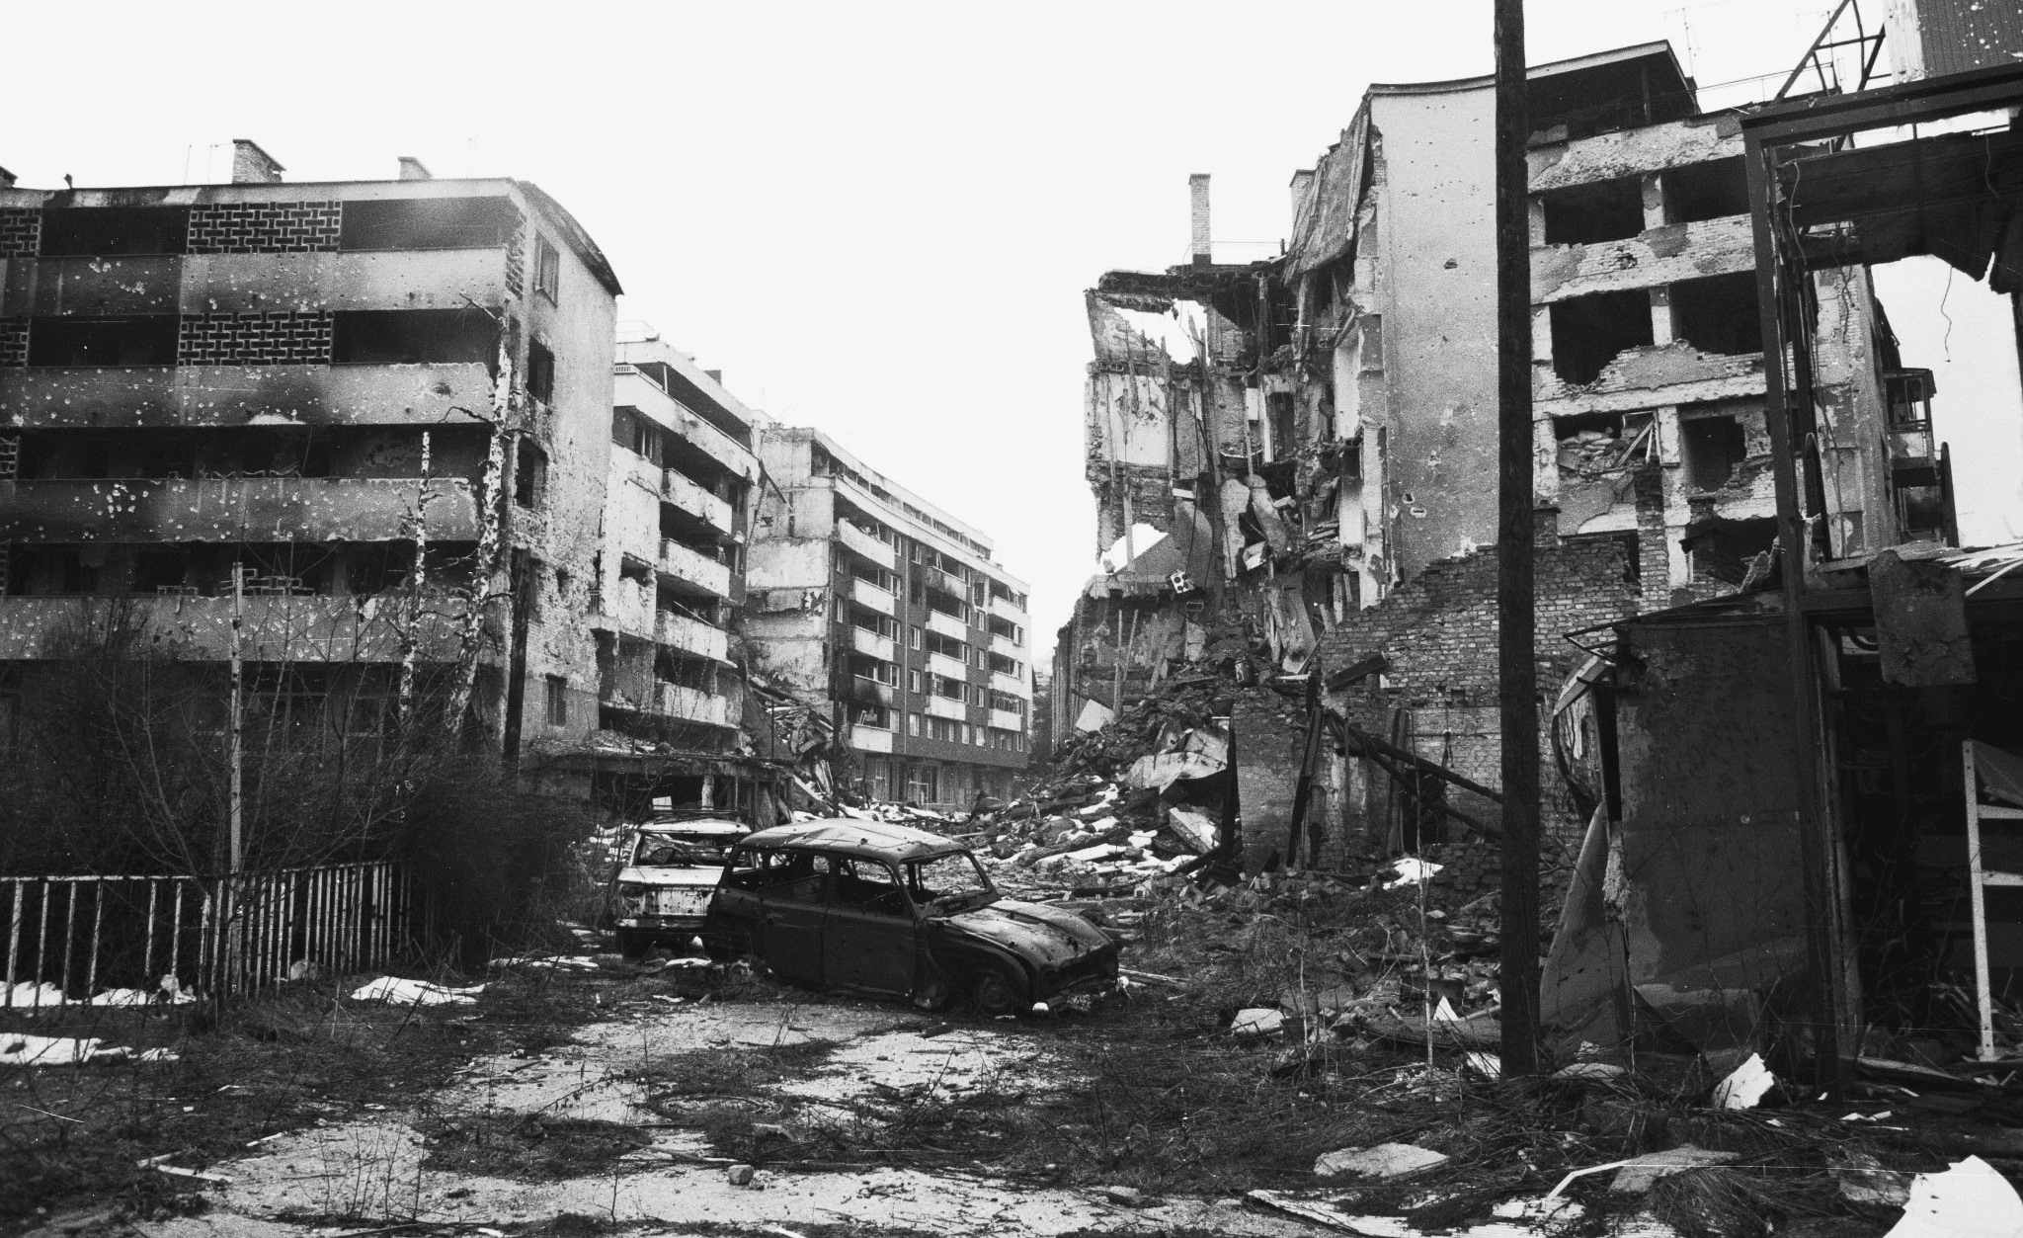
 |  |  |  | Image of a destroyed Sarajevo
The UN Abandons
What you need to know
 |  |  |  | The Bosniak Serb civil war has raged since May 1992, when Bosnian Serb under the control of General Ratko Mladić seized Sarajevo. He authorised the destruction of the city, with no regard for whether the targets were military or civilian. His forces also conducted a number of ethnic cleansing campaigns in eastern Bosnia. Because of this, thousands of Bosniaks fled to Srebrenica and Žepa, which the UN had designated “safe zones” by UNSC resolution 819 (1993), protected by Dutch UN peacekeeping forces.  On the 5th of July 1995, the Bosnian Serb army began their assault on Srebrenica, shelling the south side of the town. On the 9th, 30 peacekeepers were taken hostage by the invading force. By the 11th of July, Srebrenica was fully under the control of the Bosnian Serb army. In a meeting with the Colonel of the Dutch forces, Mladić wishes the Colonel a safe trip, and gives him a leaving present. The Dutch UN peacekeeping forces never fired against the attacking army. |  |  |  | By the 12th of July the fighting age men, of which they had a different definition than the UN definition of child soldiers, were seperated from the women, children and the elderly by the Bosnian Serb army.  It is unknown what has happened to the thousands of people who resided in the city. However as of yesterday, the 9th of August, the United States envoy to the United Nations Security Counsil, presented several photographs to said UNSC that appear to show evidence of mass graves around Srebrenica.  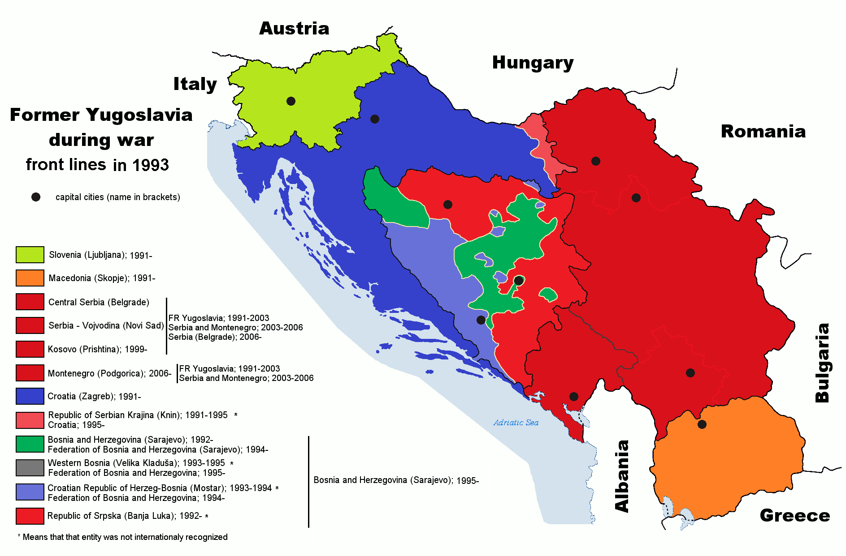  A map of the frontlines of the Bosnian civil war in 1993, as well as the rest of former Yugoslavia
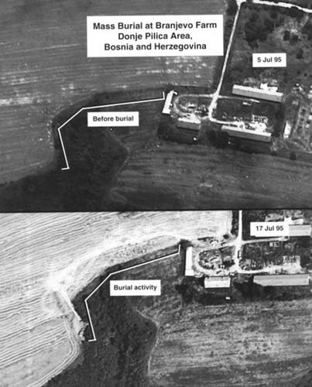
August 10th 1995 | The Eastern European Times |  |  |  | Issue #27
Peebles United Nations

The Breakup of a Nation
On the first of December 1918, the kingdoms of Serbia and Montenegro united with Dalmatia (the southernmost region of modern-day Croatia), Croatia-Slavonia (two of the other three historical regions of Croatia, with the fourth, Istria, being part of Italy at this time), Slovenia, Bosnia and Herzegovina, and Vojvodina (the northernmost region of modern day Serbia) under the rule of the Serbian Karadjordjević dynasty to create the Kingdom of Serbs, Croats and Slovenes.  The ethnic groups encapsulated in this kingdom were Serbs who are Orthodox Christians, Croats who are Roman Catholic, Slovenes who are also Catholic but speak a different language to Croats, and Bosniaks who are predominantly Muslim. The Croats argued for a federal structure in the union which respected each people's cultural belief, while Serbs, who were in power as their peoples were spread more widely over the nations within. Due to the Serb unitarist solution being adopted, insurgent nationalist movement by these ethnic groups resulted with the King Alexander the first proclaiming a royal dictatorship to replace the previous semi-democratic state, and creating the Kingdom of Yugoslavia in 1929 in an attempt to replace nationalism with Yugoslav patriotism.  This resoundingly failed, with further discontent spreading between the ethnic groups until an agreement was reached in 1939 to unite the Croat people and allow them some level of autonomy under the monarchy. This solution may have worked, but it was never fully implemented thanks to the invasion of Yugoslavia by the axis powers in 1941. |  |  | The second Yugoslavia came into existence in 1946, with Josip Broz Tito and his Partisans, a guerilla army formed by the communist party that was instrumental in the expulsion of German rule in the region, forming the Socialist Federal Republic of Yugoslavia. This was comprised of six equal republics, Croatia (now including Istria), Bosnia and Herzegovina, Serbia, Slovenia, Macedonia and Montenegro, under one federal government. The majority of decision making was still centralized, with Tito’s government and party closely mirroring that of the Soviet Union, despite not being formally part of the Union.  Much growth in the period from 1953 to 1965 was stifled by the introduction of power being held by collections of workers, who’s managers often gave sizeable wage increases beyond the rate of output of the industry in which they worked. After Tito’s death in 1980, a collective presidency took over, with representatives of many different regions in control, and with the economic problems revealing themselves in the forms of rising inflation and mass unemployment, a large amount of borrowing took place to patch over the issue. This ended in 1983 when the IMF demanded a large economic restructuring to take place to enable any further borrowing, and the discussion on how to do so reopened old animosity between the wealthier regions in the north and west who were contributing heavily to federal policies that were squandered by inefficiency in the southern and eastern regions.  This led to Slovenia and Croatia declaring independence from the union, followed by Macedonia (now North Macedonia) and in 1991. In 1992 the Bosnia held a referendum to declare independence in which 99.7% of voters voted yes. Despite this clear decision from due democratic process and its international recognition, the Serb politicians in power in Bosnia boycotted the result leading to the outbreak of civil war in Bosnia.
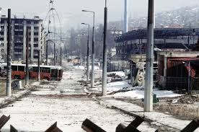 |  |  |  | Peebles Model United Nations  Potential Horrors  The events at Srebrenica, judging by the photographs has the potential to be the largest case of mass murder in Europe since the second world war. This should serve as a wakeup call to all in the west, east and all over the world to call for an immediate cease fire in Bosnia, before any more blood is shed.
Destruction of Bosnia

Welcome to PHSMUN 2025 Historical Committee, please note that we are in the time period of 1995 for this debate, any events after this are completely unknown to the country you represent, and we ask that you keep this in mind, and act accordingly. Thank you. - Chairs

