**Briefing: Addressing Human Rights Concerns and Rising Political Tensions in Ethiopia**

Welcome to PHSMUN 2025 Human Rights Council! We are your chairs – Duncan and Owen. Important things to note: we will debate TQO the Syrian Crisis on Friday the 13th, and then TQO the right to a fair trial and TQO the Ethiopian Crisis on Saturday the 14th. Delegates only attending on Saturday (as we know some of you are) should only prepare for the latter topics.

Position papers are not mandatory but submit them if you like. Resolutions (which should be submitted by any delegate hoping to win a prize) should be submitted by Thursday night if possible, and delegates should also bring a paper copy.

Both resolutions and position papers can be submitted to [gw14peppeduncan@glow.sch.uk](mailto:gw14peppeduncan@glow.sch.uk)

We look forward to seeing you all for the 3rd annual edition of the PHSMUN Conference!

**Background and Context**

Ethiopia, a nation of over 120 million people and Africa’s second-most populous country, has long been a regional power in the Horn of Africa. However, since November 2020, it has been engulfed in a devastating conflict centred in the northern Tigray region. The crisis began when the Ethiopian federal government, led by Prime Minister Abiy Ahmed, launched a military operation against the Tigray People’s Liberation Front (TPLF), the regional ruling party in Tigray, accusing it of attacking a federal military base.

This conflict quickly escalated into a broader civil war, involving regional forces from Amhara and Eritrea allied with the federal government. The fighting led to widespread destruction, massive displacement, and a grave human rights crisis. An estimated 600,000 people died during the war, and millions more were displaced. In 2022, two years after the war commenced, the Cessation Of Hostilities Agreement (COHA) was signed and the TPLF agreed to fully disarm and reintegrate Tigray into the federal government. Since then, fighting has largely stopped, though areas of Ethiopia remain unstable. Ethnic militias continue to mount attacks on the federal government: 209 incidents of political violence were recorded across just one month in 2024, resulting in 862 fatalities – and the numbers are continuing to rise.

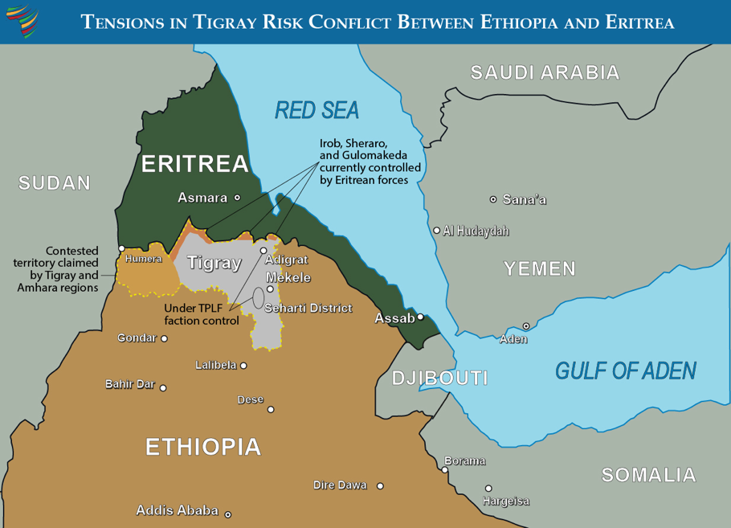Recently, tensions have been rising further in the region. Longtime TPLF leader Debretsion Gebramichael has claimed control of the Tigray Defence Forces (TDF), while Getachew Reda, president of the Tigray Interim Administration (TIA) set up under the COHA to guide reintegration, asserts that the TIA has authority over the TDF, and has accused Debretsion of destabilising Tigray and attempting to mount a coup d’etat. Many suggest that Tigray is headed for another major war in the near future due to the political turmoil, and the alleged and unauthorised Eritrean presence in the region threatens to turn any such war into a regional conflict involving other countries in the Horn.

Further detail and context on the current state of Tigray can be found here:

https://africacenter.org/spotlight/rising-tensions-tigray/

**Human Rights Crisis: Key Issues and Violations**

* Independent investigations and reports by the United Nations, Amnesty International, Human Rights Watch, and others document serious abuses, including massacres of civilians, sexual violence used systematically as a weapon of war, forced displacement, arbitrary arrests, and extrajudicial killings.
* Sexual violence has been reported on a large scale, targeting women and girls as part of the ongoing fighting between Ethiopian authorities and Tigrayan ethnic militias. Survivors face stigma and lack adequate access to medical and psychological support.
* Over 2 million people were internally displaced within Ethiopia during the conflict, while more than 60,000 refugees fled to neighbouring Sudan. Displaced populations face food insecurity, lack of shelter, and limited healthcare access. An estimated 15% of the population of Tigray remain displaced.
* Conflict, insecurity, bureaucratic impediments, and deliberate obstruction have severely limited humanitarian agencies' ability to deliver aid. Parts of Tigray have been inaccessible for months, exacerbating the crisis.
* The conflict has inflamed ethnic tensions, particularly between Tigrayans, Amharas, and Oromos. This has complicated efforts for national unity and peace.
* The conflict has disrupted agriculture, trade, and essential services, worsening poverty and food insecurity in the region and beyond.

**The United Nations’ Response**

The UN has played a multifaceted role addressing this crisis at humanitarian, political, and human rights levels:

1. **Humanitarian Assistance:**
   * UN agencies, including the World Food Programme (WFP), UNICEF, the UN Refugee Agency (UNHCR), and the Office for the Coordination of Humanitarian Affairs (OCHA), have scaled up emergency aid.
   * The WFP has provided food assistance to millions in Tigray and neighbouring regions, while UNICEF supports health services and water sanitation programs.
   * UNHCR collaborates with Sudan and other neighbours to protect refugees and provide shelter and essential services.
2. **Human Rights Monitoring and Advocacy:**
   * The Office of the High Commissioner for Human Rights (OHCHR) has deployed fact-finding missions and called for independent investigations into violations.
   * The UN Human Rights Council adopted resolutions condemning abuses and demanding accountability.
   * The UN has pressed all parties to respect international humanitarian law, protect civilians, and facilitate access for humanitarian actors.
3. **Diplomatic Engagement:**
   * UN Secretary-General António Guterres has repeatedly called for ceasefire, dialogue, and peaceful resolution.
   * Special envoys and representatives engage with Ethiopian authorities, regional actors, and civil society to promote political dialogue.
   * The Security Council has issued statements urging restraint and humanitarian access but has struggled to reach consensus on stronger action.
4. **Coordination with Regional and International Partners:**
   * The UN collaborates with the African Union (AU), Intergovernmental Authority on Development (IGAD), and neighbouring countries to mediate peace efforts.
   * Efforts are underway to address cross-border impacts and promote refugee protection.

**Challenges Faced by the UN and the International Community**

* The Ethiopian government’s control over communication and access to Tigray has impeded the delivery of aid and independent monitoring.
* Active hostilities in parts of the region continue to endanger civilians and humanitarian workers.
* The complex ethnic landscape and information warfare complicate peace-building and reconciliation efforts.
* There is a risk of a wider regional conflict breaking out, with actors such as Eritrea having an unauthorised military presence in the Tigray region.

**Possible UN Actions and Considerations**

* The UN could intensify diplomatic pressure on all parties to allow unhindered access for humanitarian aid and independent observers.
* The UN could increase support for independent investigations and mechanisms to hold perpetrators accountable under international law.
* The UN should expand resources and protection efforts for IDPs and refugees in neighbouring countries.
* The UN can facilitate inclusive peace talks involving all ethnic groups and political actors to foster national reconciliation.
* Long-term development, governance reform, and human rights protections must be part of any sustainable solution.

**Questions for Delegates**

1. What concrete measures can the UN adopt to ensure effective humanitarian access and protection of civilians in conflict zones?
2. How can the international community balance respect for Ethiopia’s sovereignty with the responsibility to protect vulnerable populations?
3. In what ways can the UN support reconciliation efforts to heal ethnic divisions and promote lasting peace?
4. How should the UN collaborate with regional organisations and neighbouring countries to address refugee protection and cross-border impacts?
5. What mechanisms should be strengthened or created to guarantee accountability for human rights abuses in Ethiopia?

Top of Form

Bottom of Form