**Background and Context**

Syria has undergone a profound political transformation since December 2024, when President Bashar al-Assad was ousted by a coalition of Islamist rebel groups, including Hay'at Tahrir al-Sham (HTS), supported by Turkish-backed factions of the Syrian National Army. This marked the end of over five decades of Assad family rule. Following the regime's collapse, a transitional government was established, and on January 29, 2025, Ahmed al-Sharaa, former leader of HTS, was appointed as interim president. He signed an interim constitution on March 13, 2025, initiating a five-year transition period. The new constitution envisions a presidential system without a prime minister and emphasises Islamic law as a primary source of jurisprudence, while pledging to protect the rights of all ethnic and religious groups. Syria has a strong base of support from other Middle Eastern nations such as Saudi Arabia and the UAE, who are keen to see the country reintegrated into the Arab League and boost regional economic prosperity. US President Donald Trump has also recently declared his support for al-Sharaa’s new government, possibly due to the abundance of unexploited natural resources such as oil in Syria.

Since the overthrow of al-Assad’s dictatorship in Syria, many have returned to their homes and the human rights situation has arguably improved. More than 500,000 Syrians have returned to the country from abroad, and 1.2 million IDPs have returned home since December 2024. The European Union recently announced its decision to lift its sanctions on Syria on a conditional basis, and the UNHCR has supported many refugees to return to the country from Jordan and other neighbouring nations.

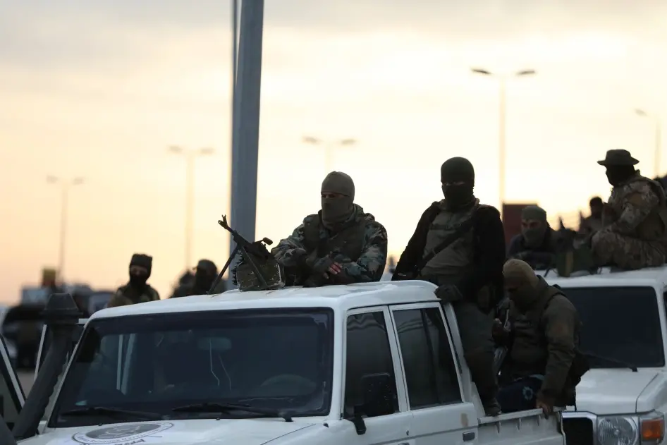Despite these commitments and improvements, Syria faces significant challenges, including ongoing sectarian violence, human rights abuses, and the need for national reconciliation. The UNHCR projected that there are still ~7.2 million IDPs and 6.2 million refugees from the country, primarily hosted in neighbouring countries of Egypt, Iraq, Jordan, Lebanon and Türkiye. Sectarian massacres continue in many areas of Syria, with the Islamist armed group HTS and the Turkish-backed SNA both allegedly abusing, torturing and executing ethnic groups, particularly the Alawite and Druze minorities, in northern Syria and other regions.

*Armed groups, including those backed by the Syrian government, continue to fight in some areas of Syria.*

Furthermore, the Israeli government continues to occupy the Golan Heights region and has plans to illegally double the settler population in the region by 2027. Israel has also conducted military strikes against Syrian installations with the stated intention of creating a “buffer zone” along the border.

**The United Nations' Response**

**1. Humanitarian Assistance**

UN agencies, including the World Food Programme (WFP), UNICEF, and the UN Refugee Agency (UNHCR), continue to provide aid to displaced populations and host communities. Efforts focus on food security, healthcare, education, and protection services.

**2. Human Rights Monitoring**

The UN Human Rights Council has established a commission to investigate alleged human rights violations in Syria.However, access to certain areas remains restricted, complicating efforts to document abuses and ensure accountability.

**3. Diplomatic Engagement**

The UN supports the transitional government's efforts to establish a new constitution and promote national reconciliation. The Security Council has called for an inclusive political process and the protection of human rights for all Syrians.

**Major Challenges and Obstacles**

* **Sectarian Tensions:** Deep-rooted sectarian divisions pose significant obstacles to national unity and reconciliation efforts.
* **Impunity:** Ongoing human rights abuses by various factions contribute to a climate of impunity, undermining trust in the transitional government.
* **Humanitarian Access:** Continued insecurity and logistical challenges impede the delivery of humanitarian assistance to those in need.
* **International Support:** While some international actors have provided support to the transitional government, geopolitical rivalries and differing interests complicate coordinated international assistance.

**Considerations for Delegates**

* **Promoting Accountability:** What measures can the UN take to ensure accountability for human rights violations committed by all parties?
* **Supporting Reconciliation:** How can the UN assist in fostering national dialogue and reconciliation among Syria's diverse communities?
* **Ensuring Humanitarian Access:** What steps can be taken to guarantee unimpeded humanitarian access to all affected populations?
* **International Cooperation:** How can the international community support Syria's transition while respecting its sovereignty?

Top of Form

Bottom of Form