PHS MUN 2026
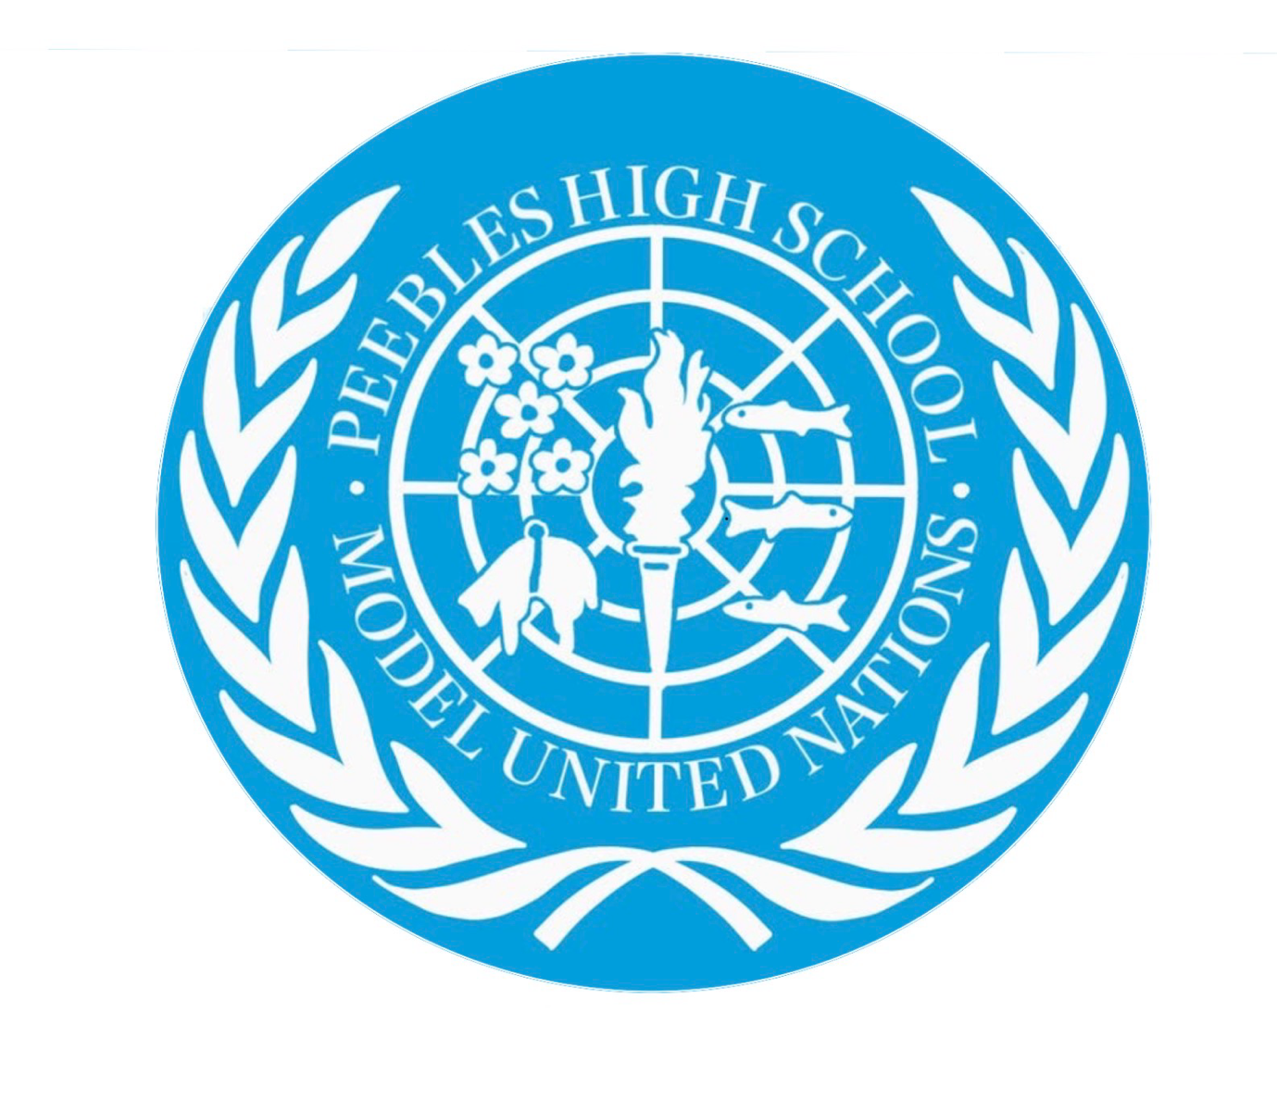
United Nations security council: topic 2, The issue of Taiwan
Lochain McNae and Emma Humphreys

The Taiwan issue has been a long-standing challenge to international peace and security, involving the People's Republic of China (PRC), Taiwan and international powers, particularly the United States. Taiwan is a self-governing democracy in East Asia, located across the Taiwan Strait from mainland China. Beijing claims Taiwan as part of China and has not ruled out the use of force to achieve unification. Taiwan's government maintains that its future should be determined by its people and seeks to preserve the existing situation across the Strait.
The region holds significant strategic and economic importance due to its position in the western Pacific, major international shipping routes, and Taiwan's leading role in the global semiconductor industry. Any military confrontation could disrupt international trade, damage the global economy, and increase the risk of a wider conflict involving major powers.

Background
Several historical developments have shaped the current situation:.
- 1949: Following the Chinese Civil War, the People's Republic of China was established on the mainland, while the Republic of China government retreated to Taiwan. The two sides have since been governed separately.
- 1971: UN General Assembly Resolution 2758 recognised the representatives of the People's Republic of China as the only lawful representatives of China at the United Nations, replacing the Republic of China delegation. Disagreement continues over the resolution's implications for Taiwan's international status and participation in international organisations.
- 1979: The United States established diplomatic relations with the People's Republic of China while maintaining unofficial relations with Taiwan.
- 1990s: Taiwan developed into a democratic political system, while cross-strait relations continued to fluctuate between economic engagement and political and military tension.
- 2022: Following a high-profile visit by then-US House Speaker Nancy Pelosi to Taiwan, China conducted major military exercises around the island. Military activity and political tensions have remained important regional security concerns.
- 2026: Military activity around Taiwan and tensions over cross-strait relations continued. In October, Taiwan monitored Chinese military exercises in several coastal areas, while reporting also highlighted concerns over maritime activity around Taiwan and its outlying islands.

Taiwan and China
The central issue is the disagreement over Taiwan's political status and future. The People's Republic of China considers Taiwan part of its territory and supports eventual reunification, while Taiwan works its own government, military, elections and institutions.
China has increased military activity around Taiwan and maintains that it may use force if necessary to achieve unification. Taiwan views such pressure as a threat to its security and democratic self-government.
Key question: How can the Security Council reduce the risk of conflict while encouraging peaceful dialogue and avoiding unilateral changes to the status quo?

China and the United States
Relations between China and the United States are a major factor in cross-strait tensions. Washington maintains unofficial relations with Taiwan and provides support for its defensive capabilities, while also maintaining its own diplomatic framework with Beijing. China opposes US arms sales and other forms of security cooperation with Taiwan, viewing them as interference in its internal affairs.
A confrontation could involve the world's two largest economies and disrupt regional security, international trade and semiconductor supplies.
Key question: How can China and the United States improve communication, reduce military miscalculation and prevent a dispute over Taiwan from developing into a wider international conflict?

Regional Security and Maritime Trade
The Taiwan Strait is an important route for international shipping. Military exercises, maritime confrontations or a blockade could disrupt trade and supply chains, particularly in electronics and semiconductor manufacturing.
Japan, South Korea, the Philippines and other regional states have an interest in maintaining peace and stability in the western Pacific. Increased tensions could also place pressure on regional alliances and raise concerns about the security of nearby islands and maritime routes.
Key question: How can the international community protect regional stability and freedom of navigation while encouraging the peaceful resolution of disputes?

Taiwan's International Status
Taiwan's participation in international organisations remains contested. UN General Assembly Resolution 2758 established that the People's Republic of China represents China at the United Nations. However, there is disagreement over whether and how the resolution affects Taiwan's participation in international organisations beyond the question of China's representation.
China argues that Taiwan is part of its territory and opposes Taiwanese participation in international bodies where it considers this inconsistent with its one-China principle. Taiwan's government argues that the resolution does not determine Taiwan's sovereignty or prevent its meaningful participation in international cooperation.
Key question: How can the international community encourage practical cooperation with Taiwan, particularly in areas such as public health, aviation safety and disaster response, while recognising the diplomatic disagreements surrounding its status?

Prior actions by the UN and international community
Important documents and policy frameworks include:
- UN General Assembly Resolution 2758 (1971): Established the representation of the People's Republic of China at the United Nations.
- UN Charter (1945): Provides the legal framework for the peaceful settlement of disputes and the prohibition on the threat or use of force against states' territorial integrity or political independence, subject to recognised exceptions.
- US–China diplomatic arrangements (1979): Established formal diplomatic relations between the United States and the People's Republic of China.
- Taiwan Relations Act (1979): US domestic legislation governing unofficial relations with Taiwan and the provision of defensive support.
- UN General Assembly Resolution 2625 (1970): Sets out principles of international law concerning friendly relations and cooperation among states, including peaceful dispute settlement.
Unlike the Middle East, Taiwan is not the subject of a comparable series of dedicated Security Council resolutions establishing a ceasefire or peacekeeping mission. The UN's diplomatic framework is complicated by the fact that the People's Republic of China is a permanent member of the Security Council.

Points to consider when researching
Delegates could consider the following measures:
- Diplomatic dialogue: Encourage communication between Beijing, Taipei and relevant international actors to reduce misunderstandings and prevent escalation.
- Crisis communication: Support reliable communication channels and emergency procedures to reduce the risk of accidental military confrontation.
- Military de-escalation: Encourage restraint, advance communication about military exercises where appropriate, and measures that reduce the risk of miscalculation.
- Peaceful dispute resolution: Reaffirm the importance of peaceful dialogue and oppose the use of force to resolve disputes.
- Economic stability: Encourage cooperation to protect international trade, semiconductor supply chains and maritime transport from disruption.
- Practical international cooperation: Explore ways to support Taiwan's participation in appropriate international technical and humanitarian activities, where this is consistent with the relevant organisations' rules and diplomatic arrangements.
A strong resolution should prioritise preventing conflict, improving communication and supporting peaceful dispute resolution. Delegates should also consider the Security Council's legal authority, the positions of its permanent members and the practical limits of UN action.

Delegate research
Delegates should research their assigned country's official policies, diplomatic relationships and voting record. Potential priorities include:
- China: Territorial integrity, the one-China principle, opposition to Taiwanese independence and opposition to foreign military involvement.
- United States: Peace and stability across the Taiwan Strait, unofficial relations with Taiwan, defensive support for Taiwan and management of competition with China.
- United Kingdom and France: Regional stability, peaceful dispute resolution, international law and the protection of international trade.
- Japan: Regional security, stability in nearby waters and the potential economic and security consequences of a Taiwan Strait conflict.
- Australia: Regional stability, maritime security, economic resilience and cooperation with regional partners.
- Russia: Strategic relations with China, sovereignty and opposition to what it regards as Western interference.
- Philippines: Regional maritime security, economic ties and the security implications of tensions in nearby waters.
- Taiwan's authorities: Preservation of the existing situation, democratic self-government, international participation and maintaining peaceful cross-strait relations. Taiwan is not a UN member and does not hold a seat on the Security Council.
These are broad starting points rather than complete or definitive statements of current policy. Delegates should consult recent official statements and consider how their assigned country's position has evolved.
Point: Delegates should conduct extensive research into their country's foreign policy, particularly its position on China, Taiwan, sovereignty, the use of force and regional security. They should arrive prepared to explain which proposed measures their country would support, oppose or seek to amend.

Useful Research Links
The following sources can help delegates understand the history of Taiwan, verify recent developments, prepare country positions, and draft resolutions.
1. UN Security Council: https://www.un.org/securitycouncil/
Official meetings, resolutions and information about the Council's role in maintaining international peace and security.
2. UN General Assembly Resolution 2758: Read the official resolution
3. UN Charter: https://www.un.org/en/about-us/un-charter/full-text
Relevant legal principles, including peaceful dispute settlement and the prohibition on the threat or use of force.
4. Taiwan's Mainland Affairs Council: https://www.mac.gov.tw/en/
Official information on Taiwan's cross-strait policy and its position on maintaining peace and stability..
5. Council on Foreign Relations: Confrontation Over Taiwan
Independent analysis of tensions, military activity and recent developments.
Reducing tensions across the Taiwan Strait requires sustained diplomacy, effective crisis communication and a commitment to resolving disputes peacefully. The Security Council must consider the risk of military escalation, the economic consequences of conflict and the competing political positions of China, Taiwan, and other international actors.
Delegates should focus on practical measures that reduce the risk of miscalculation, encourage dialogue and protect regional stability, while recognising the limits of the Security Council's authority and the importance of international law.
Research note: The situation is rapidly changing. Delegates should stay informed on recent developments in order to gain a better understanding of the conflict and the issue as whole.

