**Introduction**

Welcome to NAC, this committee is slightly different to most as NAC is not a United Nations committee meaning its priorities are slightly different: NAC’s focus is mostly military and humanitarian so when making decisions in this committee delegates should think of their countries position on the issue and work out what military action would advance those goals the most. NAC is also debated clause by clause this means no resolutions need to be submitted, we recommend writing a number of clauses that can then be suggested individually.

This is the debate on Ukraine and due to the difficulty of the situation in Ukraine this briefing will assume a base level of understanding and knowledge relating to this topic, also due to the speed at which updates this may be out of date by the time the conference and so will assume delegates paying attention to the news and new developments in Ukraine.

**Actions taken by NATO**

NATO created CAP, a comprehensive assistance package to support Ukraine including:

* Immediate Support: Provision of non-lethal military aid, including medical supplies, fuel, clothing, and communication systems
* Long-Term Assistance: A multi-year program focusing on rebuilding Ukraine's defense sector and transitioning towards NATO interoperability
* Financial Contributions: As of February 2025, Allies and partners have contributed over €955 million to the CAP Trust Fund

NATO Security Assistance and Training for Ukraine (NSATU)

* Coordination of Aid: Manages the supply of military equipment, such as Stinger missiles and Leopard 2 tanks, and oversees their maintenance and logistics
* Training Programs: Organizes training for Ukrainian forces at NATO facilities
* Operational Hubs: NSATU operates from Wiesbaden, Germany, with logistical hubs in Eastern Europe

NATOestablished a NATO-Ukraine Council facilitating equal participation in decision-making, Serves as a platform for joint consultations and coordinated activities, enhancing political dialogue and cooperation.

NATO created the Operational Force Development Framework (OFDeF) which is a Ukrainian-driven process supported by NATO, focusing on innovative approaches to training, equipment, and supply chain issues.

**Peace**

In May 2025 Russia and Ukraine made a prisoner exchange deal with each side releasing 1000 individuals in phases, of mostly military personnel, however broader peace negotiations are stalled due to Russias high demands, including territorial resignation and the prevention of Ukrainian NATO membership.

The USA has been promoting peace talks, with a number of deal suggestions with, at the time of writing, the most recent suggestion has been a 30-day ceasefire with the Vatican acting as a mediator however this has been shot down by Russia and has been questioned in the deathless by Ukraine.

The most important block to peace are the issues around NATO membership prospects, the disagreement over territorial claims of both Ukraine and Russia and different political differences.

**Actions taken by individual countries**

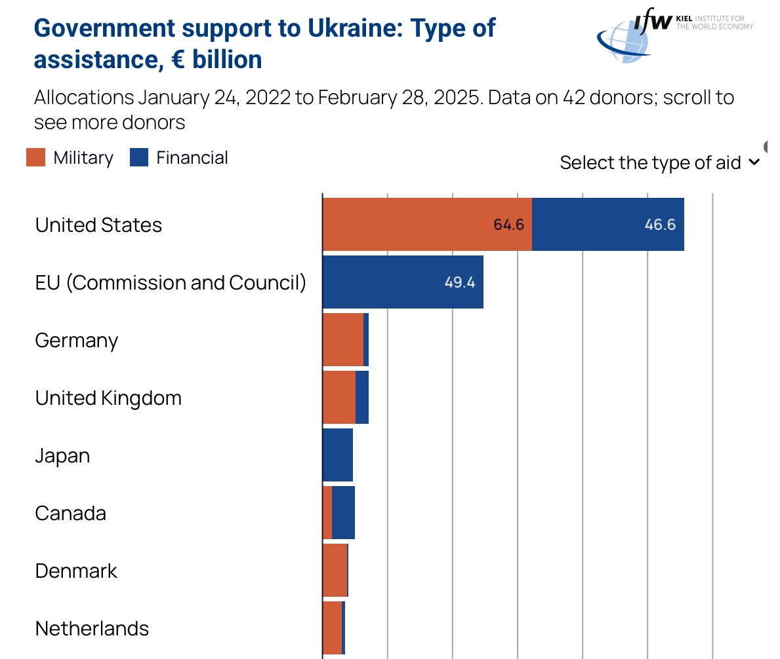

<https://www.ifw-kiel.de/topics/war-against-ukraine/ukraine-support-tracker/>

Many countries have done a number of things to do with committing more into the support of NATO allies and Ukraine, for example Germany has established its first permanent foreign military brigade for the first time since WWII, Sweden fully broke its neutrality that had been standing sines the early 19th century joining NATO as did Finland who joined in 2024 and 2023 respectively.

In march 2025 leaders from 18 countries, including Ukraine, the UK, France, Germany, and Italy, convened to discuss a path to peace. They agreed that any lasting ceasefire must ensure Ukraine's sovereignty and security. A "coalition of the willing" was proposed, consisting of nations prepared to defend the terms of any peace agreement and guarantee Ukraine's security afterward. In February 2025 the Weimar+ Alliance was Established, this diplomatic group includes France, Germany, Poland, the UK, Italy, Spain, and the European Commission. It was formed in response to shifts in U.S. policy and aims to ensure European unity in supporting Ukraine's sovereignty and participation in peace negotiations.

The international community as a whole has emphasised the need for and importance of Ukraine safety guarantees and there has been a lot of support militarily and financially for Ukraine from many countries. The coalition of the willing is a group of 31 countries which have pledged support to Ukraine militarily and economically and with the preparation for peacekeeping forces if a ceasefire is agreed upon.