February 10th 1998 | THE BELFAST TELEGRAPH  Latest news and bulletin updates |  |  |  |  |  |  |  | Issue  #10
Peebles Model United Nations  The Troubles Grow  What you need to know  Conflict grows in afflicted regions across Northern Ireland. This year marks around 30 years of fighting between several factions including the Irish Republican Army, the Ulster Volenteer Force, the Irish Liberation army and the British army.  The death toll present in the region has risen above 3,500. Over 50% of which have been confirmed as civilian casulties. Warnings to remain inside and vigilant from the British Government are still in place, with many wondering how long the sparadic and brutal fighting will continue on for.  The conflict has been fueled by Secrarian division, political disputes and the longstanding rule of the British Government, which has been tested in recent decades, as division within the country, both political and sectarian grows.  The first British troops were deployed in 1969, sparking the direct conflict which was felt hardest in 1972, when 472 people lost their lives. Since then, fighting has been feircest in specific regions of the country such as Armagh, Belfast, Derry, and the Border regions, sparking the Irish Republican Armies ‘Border Campaign’. |  |  |  | 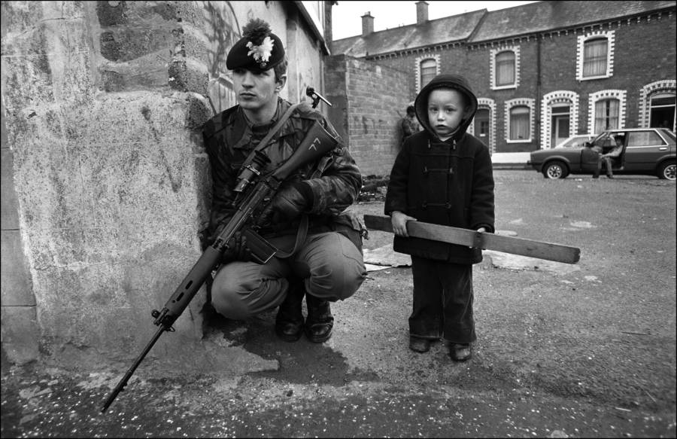
 |  |  |  | Image of professional soldiery stationed in Northern Ireland, accompanied by a small child, surrounded by upset infrestructure.
 |  |  |  | A Nation Divided
 |  |  |  | Belfast is seeing perhaps some of t The conflict spanning the past 30 years has been sparadic and violent, with some regions of the country seeing heavy fighting, protesting, bombing, and demonstrations. The most extensive divison of the conflict. The city is torn by what are known as ‘Peace Walls’. Erected in an attempt to limit sectarian violence, these walls divide battling communities and stopping direct contact between these communities. As of today, 67% of deaths have occured withing 500 meters of these structures. Belfast also has seen some of the most frequent bombings, protests and terrorist attacks during the war, making it one of the most unsafe and dangerous theatres of battle.  Derry is also seeing violence. Much of can be attributed to civil unrest. Violent protests and riots are prominent in Derry, as well as violence between gangs of youth from March 29th which sparked nearly nightly riots for much of the early conflict.  Armagh saw much fighting, particularly in the town of Bressbrook, which saw 21 British soldiers killed by the Irish Republican Army, and 4 more die from non-combat related injuries. Last year in 1997, British Army Lance Bombardier Stephen Restorick, marking the latest British Soldier to be killed. |  |  |  | The Border Regions have also seen extensive fighting, the Irish Republican Army launched their ‘Border Campaign’ attempting to seize key areas around the border between Nothern and Southern Ireland. The fighting has only escalated since the campaign begun in 1956, with both sides now struggling over these regions.  The issues and division has been present in Ireland for decades, when Protestant and Catholic Irish have long sparked issues and conflict over Northern Ireland’s relationship with Great Brtain, making the issue extremely controversial and difficult to discuss in both local and international organisations.  Humanitarian concerns have been raised in recent years and since the conflicts beginning, as both sides have been reported to target civilians and public infrastructure. Organisations struggles, with religious and militant concerns being ever present in the region.
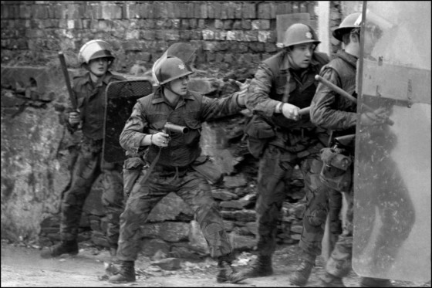
Image of professional soldiery being shielded as they enter a building.
February 10th 1998 | The Belfast Telegraph |  |  |  | Issue #10
Peebles United Nations

The Key Players
Currently, the frontlines of the conflict are fought between two major factions: the Irish Republican Army and the British Army.  The Provisional IRA has as of this year an estimated 500 active fighting members, a drop from the 1,500 reported in 1972, and a total 10,000 reported in the 30 years since the outbreak of fighting.  The British governments response entitled ‘Operation Banner’ has seen numbers of deployed combatants peak at 21,000, the majority of which from the British Army. However it is estimated that 300,000 personel have contributed to the operation thus far, including in logistical, medical, humanitarian and other non-combat roles. |  |  | Both sides have exchanged in brutal urban fighting since the conflict arose in 1969, with military forces being supplimented with civilian riots and demonstrations.  The Irish Republican Army utalises terrorist methods including sniper fire, bombings, arson, guerilla warfare, and hostages used in both demmands and proxy bombings. While both sides have faced accusations of civilian targetting, the IRA has found civilians and public buildings in their crossheirs many times during the fighting, increasing collateral damage.  The British Army has largely been a response unit, attempting to cease violence and eliminate any threats that arise before they can be realised. The British Army has also been accused of civilian targetting and collateral damage.
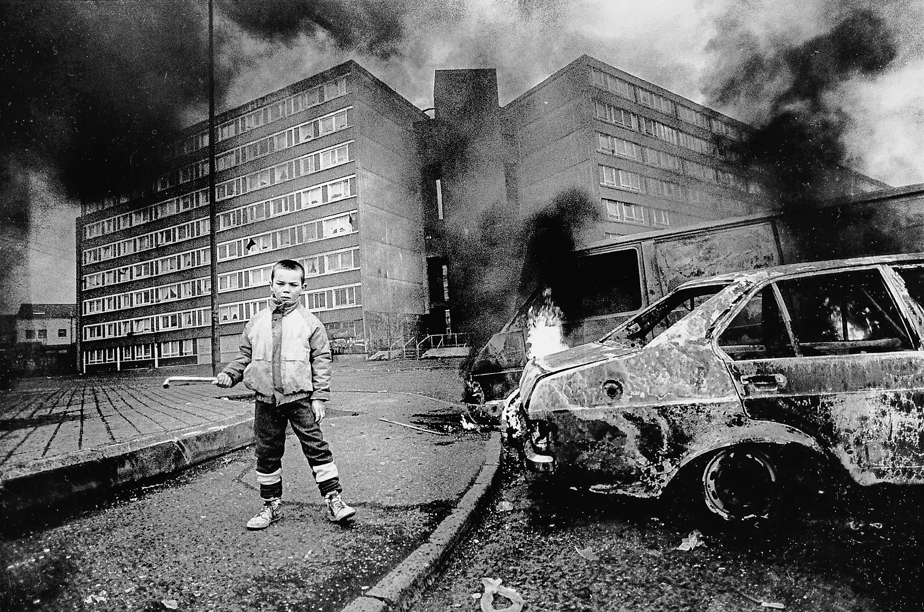 |  |  |  | Peebles Model United Nations  The United Nations  The latest updates  In one of the first international responses to the conflict, an emergency meeting of the united Nations has been called in Peebles, Scotland, in order to discuss the issue of The Troubles.  The meeting is to take place, controversially, in Scotland. Many Britsh loyalists have taken an issue to this however, as Scotland is home to many IRA sympathisers, safehouses and fundraisers which support the Irish militant group, and have criticised the UN for this decision.  Countries will meet from across the globe to discuss humanitarian, military, and economic solutions to the conflict. However, this may be challenging, as religious division spells problems for any meaningful response without sparking mass outrage.  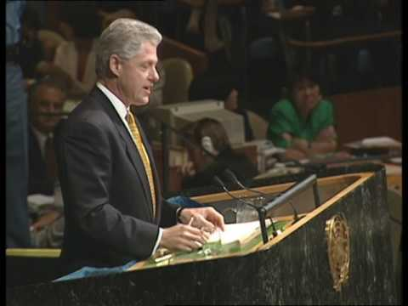
Irish Child captured infront of damaged flats and destroyed and burning cars.

Peebles Model United Nations

A Country Devasted
As of today, civilian casulties mount at a staggering 1,879 lives lost, with military soldiers contributing an additional 1500, making the total number of lives lost as a result of the conflict over 3,500 and rising.  Civilian deaths have been a result of mass collateral damage causes by indescriminate weapons such as bombs and high explosive devices, often strapped onto captured hostages by the IRA, and used as suicide bombers against British positions. |  | Additionally, the damage on the region has been extensive in both structural and economic devastation. Housing being destroyed has resulted in homelessness, with 23,000 people being made homeless in Belfast alone.  Additionally, approximately 50,000 Northern Irish civilians have fled the country as a result of IRA intimidation, causing influxes in Scotland, England and Wales, creating cultural divides.
 |  |  |  | President Clinton at 53rd UN General Assembly (1998)

Welcome to PHSMUN 2025 Historical Committee, please note that we are in the time period of 1998 for this debate, any events after this are completely unkown to the country you represent, and we ask that you keep this in mind, and act accordingly. Thank you. - Chairs

