PHSMUN 2026
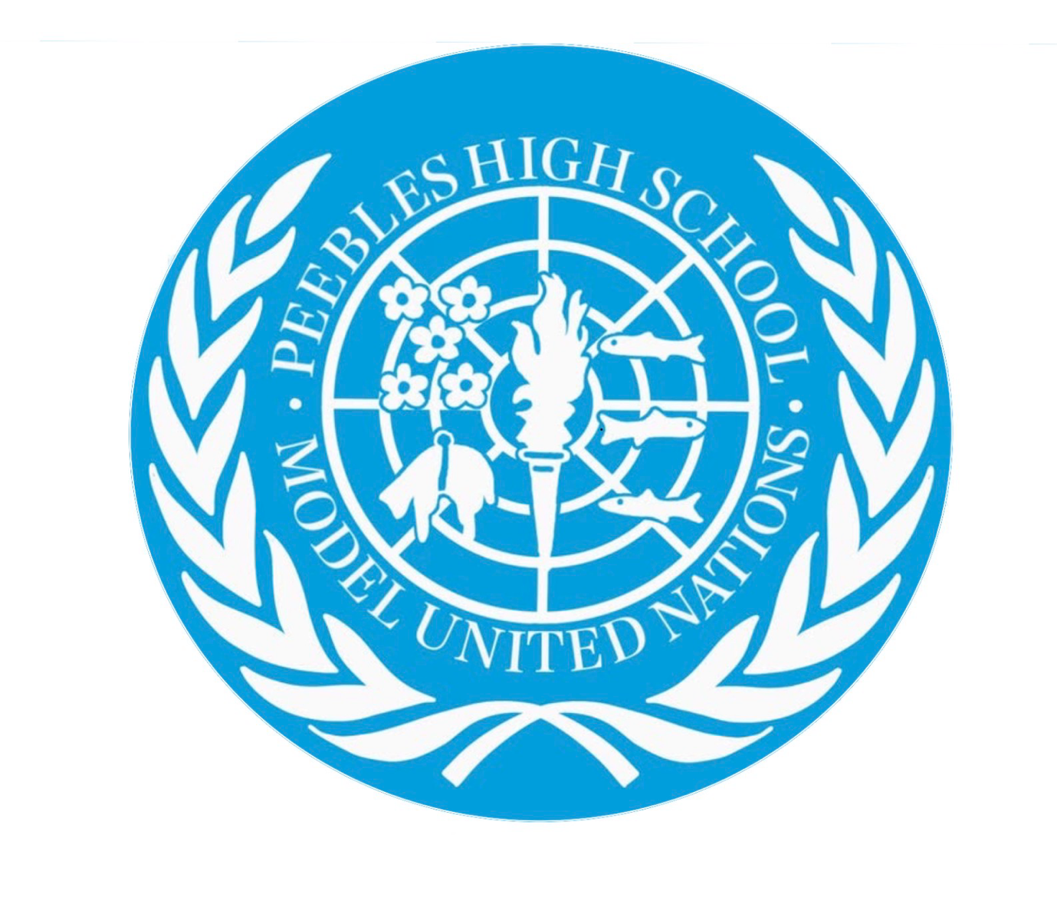
Historical committee: Topic 3, the Soviet invasion of Afghanistan and its implications for international peace and security.

Chairs: Faith Salmond and Luc Mcmenamy

Brief context:
On December 24th, 1979, the Soviet Union invade Kabul with massive force. This happened under the guise of helping Afghanistan’s struggling government in their fight against the anti-communist guerrilla groups the government found opposing them. During this time, the Cold War is raging and there have been many tense stand offs, the Soviet invasion of Afghanistan was viewed by the USA as blatant Soviet expansion, a play for power which they couldn’t oppose due to the stalled nature of the situation. This was important to the global political situation as it represented the shift to the second Cold War. As a reaction, the USA imposed heavy trade embargoes and undertook other significant actions. Delegates must appreciate the fragility of the situation and the tense standing of the global political landscape.
In 1978, Afghanistan’s centrist government was overthrown by left wing parties which then shared power, the new government had only a fragile coalition and little support within Afghanistan. To back their strength, the government created very strong ties with the Soviet Union through their shared ideologies (Marxism and Leninism). The government squashed all opposition and immediately began proposing massive reforms to the traditionally Muslim country. Many traditional groups rebelled and rose up against the government. Uprisings were led by a group called the Mujahideen. The uprisings and the lack of support for the communist government caused the Soviet Union to invade in order to keep Afghanistan communist. The action was widely condemned by member states. The Soviet Union invaded to protect the allied government against growing armed resistances in Afghanistan and also to protect their own border. When the Soviets entered they killed the Afghan leader and replaced him with Babrak Karmal, an act which destroyed their guise of wanting to help the Afghan government.
International reactions:
The USA was completely opposed to the invasion as they saw it as a blatant Soviet expansion and a power move in the tense time of the Cold War. They reacted harshly against the Soviet Union because of their decision.
Pakistan and China both expressed concerns about Soviet influence spreads and affecting their neighbouring countries, potentially putting them in danger of invasion or affecting their trade routes and alliances.
India maintained a delicate relationship with the Soviet Union throughout this time, despite the Prime Minister voicing private concerns about Soviet influence over countries.
Britain strongly backed the USA in their operations to help Afghanistan, loudly opposing the Soviet Union.
Other European countries maintained trade alliances and agreements with the Soviet Union or politically condemned them.

Questions around international law:
The Soviet invasion violated customary international law and UN charter article (2(4)) in relation to the sovereignty and political independence of a country. In their invasion and occupation of Afghanistan, they violated Afghanistan’s political independence and their sovereignty. The Soviet Union argued that they were invited by the government to assist against rebel groups but this was disputed due to the fact they had killed the previous leader of Afghanistan.
The soviets argued that because they had signed a ‘treaty of friendship, good neighbourliness and cooperation’ with Afghanistan which supposedly allowed for armed aid if it was requested. They also argued that they were protecting a communist state from western influences.
The USA also violated international law when they began to back the Mujahideen against the now Soviet government. Their massive and unabashed support of the rebel group was a clear violation of Afghan sovereignty. It was justified as liberation from the Soviet Union but the violations by both of these powerful countries called into question the power of international law when the USA and Soviet Union could do essentially what they wanted.

Key issues for debate:
Should Soviet troops immediately withdraw, or would that leave Afghanistan vulnerable?
How can delegates ensure the protection of sovereignty?
How can delegates uphold international law and ensure there will be no further violations?
Should there be sanctions for the Soviet Union?
How can the committee ensure that there is no further escalation to the Cold War?
How much support will the people of Afghanistan need and how can we give it to them?
What further humanitarian assistance will this conflict need and what further steps will need to be taken to prevent further conflict?

Good questions for delegates to research:
What is your country’s position on Soviet military intervention?
What is your country’s relationship with the Soviet Union?
What actions can the UN take?
What actions should the UN take?
How did the last war affect your country (how hard will you fight for peace)?
How can the crisis be solved peacefully?

Research sources:
https://www.un.org/en/about-us/un-charter
Information about international law and rules around this and other, similar issues.
https://adst.org/2014/12/the-soviet-invasion-of-afghanistan-december-1979/
Information about the actual invasion, the situation leading up to it and the history of Afghanistan.
https://digitallibrary.un.org/
Information about the UN up to that point and historic developments important to the situation.
https://history.state.gov/milestones/1977-1980/soviet-invasion-afghanistan
The invasion from a western point of view.
https://www.britannica.com/event/Soviet-invasion-of-Afghanistan
The invasion in respect to the history of Afghanistan and the following civil war.

Delegates should aim to create a peaceful conclusion to this issue which doesn’t escalate the tensions within the Cold War between massive world powers. This is a delicate yet pressing issue which must be addressed with diplomacy, intelligence and compassion. Please keep in mind the historical context and the year of the debate (27th December 1979).

