PHS MUN 2026
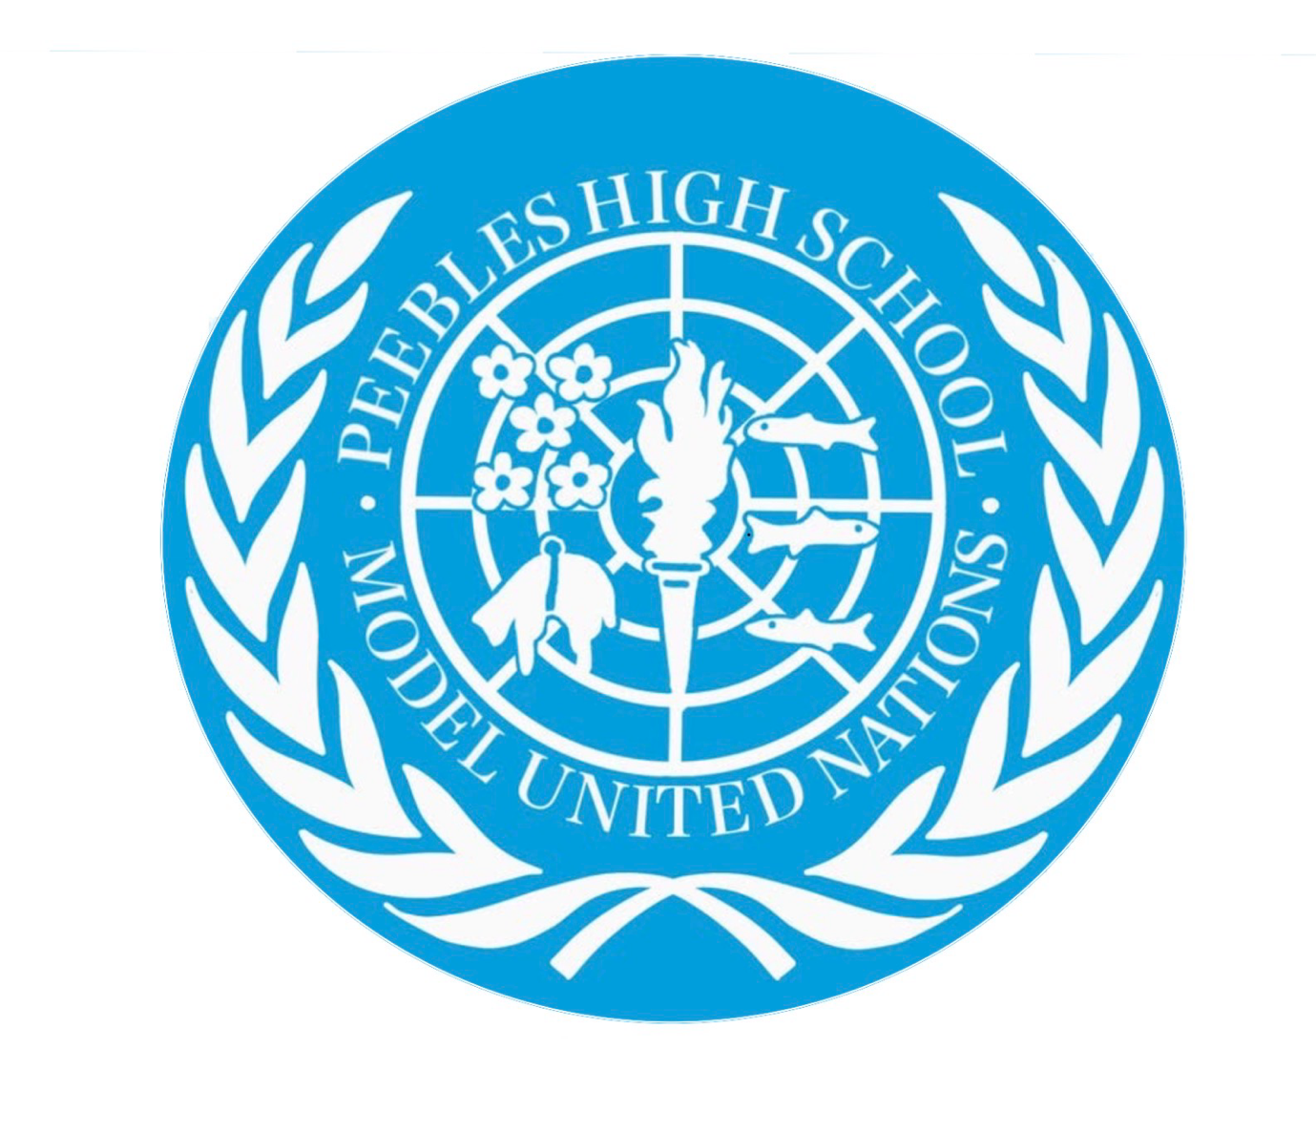
United Nations security council: topic 1, reducing tensions in the Middle East
Lochain McNae and Emma Humphreys

The issue of the Middle East has been a long-standing concern and challenge to the United Nations security council with tensions across the entire region in Isreal Palestine Iran Lebanon and Yemen as-well as longstanding international involvement in the region from countries such as the USA and Russia. The region holds great strategical and economic value in the modern world with rich resources and key shipping routes.
The Security Council must consider how to prevent further escalation, protect civilians, support diplomatic negotiations, and address the challenge underlying causes of conflict.
Background
Several historical developments have shaped the region's current conflicts:
- 1948: The establishment of Israel and the displacement of many Palestinians contributed to the continuing Israeli Palestinian conflict.
- 1967: The Arab Israeli war resulted in Israel occupying the West Bank, East Jerusalem, and Gaza, creating enduring disputes over territory and Palestinian self-determination.
- 1979: The Iranian Revolution transformed Iran's relationships with Israel, the United States, and neighbouring states.
- 2003: US invasion of Iraq in search of Salam Hussain destabilising the region for years to come
- 2011 onwards: The Arab Spring and subsequent conflicts, particularly in Syria and Yemen, increased instability, and foreign intervention.
- 2023 onwards: The Hamas-led attacks on Israel on 7 October 2023 and Israel's subsequent military campaign in Gaza intensified regional tensions, including confrontations involving Iran, Israel, and Hezbollah.
- 2026 onwards: United States military operation in Iran
- 2026: bombing of multiple sites across the Middle East by Iran in retaliation to American strikes followed by the shut down of the straight of Hormuz
- 2026: Houthi rebel strikes on Saudi Arabia and other gulf states and the ongoing conflicts in Yemen leading to further congestion of the straight of Hormuz

Israel and Palestine
The conflict remains central to regional instability. Gaza has experienced extensive destruction, displacement and humanitarian suffering. Disputes over ceasefire implementation, governance, security and humanitarian access continue, alongside tensions and settlement activity in the West Bank.
Key question: How can the Security Council support a lasting ceasefire, protect civilians, and improve humanitarian aid to the area

Iran, Israel and the United States
Confrontation between Iran, Israel and the United States has increased the risk of a wider regional war. Disagreements over Iran's nuclear programme, military capabilities and regional influence remain significant obstacles to diplomacy.
Key question: How to prevent military escalation? And how to prevent nuclear threats across the Middle East as whole?

Lebanon
Fighting involving Israel and Hezbollah has threatened civilian safety and displaced communities. UN Security Council Resolution 1701 (2006) provides an important framework for improving security along the Israel–Lebanon border.
Key question: How can the UN strengthen ceasefire arrangements and improve stability?

Syria
Following the fall of Bashar al-Assad's government in December 2024, Syria entered a period of political transition. Challenges include establishing stable institutions, protecting minority communities, supporting displaced people and preventing renewed conflict.
Key question: How can the international community support an inclusive and peaceful political transition?

Yemen and Maritime Security
Yemen continues to face political fragmentation and humanitarian challenges. Attacks and threats affecting Red Sea shipping have also connected the conflict to international trade and regional security.
Key question: How can the UN revive negotiations and improve maritime security while addressing Yemen's humanitarian needs?

Prior actions by the UNSC regarding the Middle East
Important resolutions include:
- Resolution 1701 (2006): Israel–Lebanon security arrangements.
- Resolution 2334 (2016): Israeli settlements in the occupied Palestinian territory.
- Resolution 2720 (2023): Humanitarian assistance to Gaza.
- Resolution 2722 (2024): Houthi attacks on shipping in the Red Sea.
- Resolution 2803 (2025): Framework for implementing the Gaza peace plan.

Points to consider when researching
Delegates could consider the following measures:
- Regional diplomacy: Establish communication channels and negotiations between rival states to prevent military escalation.
- Humanitarian assistance: Demand safe humanitarian access, protect medical facilities and workers, and support displaced civilians.
- Political negotiations: Support a two-state solution, inclusive governance in Syria and renewed peace talks in Yemen.
- Monitoring and accountability: Strengthen UN reporting on ceasefires and alleged violations of international law.
- Maritime security: Encourage regional cooperation to protect international shipping and prevent attacks on commercial vessels.
- Reconstruction: Support the rebuilding of essential infrastructure and services in conflict-affected areas.
A strong resolution should combine immediate measures to reduce violence with longer-term diplomatic initiatives.

Delegate research
Delegates should research their assigned country's official policies. Potential priorities include:
- United States: Israeli security, regional deterrence and maritime security.
- China and Russia: Sovereignty, diplomatic negotiations and opposition to certain forms of Western intervention.
- United Kingdom and France: International law, humanitarian protection and diplomatic solutions.
- Iran: Sovereignty, sanctions, deterrence and opposition to Israeli and US military action.
- Saudi Arabia and other Gulf states: Regional stability, economic development and protection of critical infrastructure.
- Egypt and Jordan: Palestinian displacement, border security and a negotiated Palestinian state.
- Lebanon: Territorial integrity, civilian protection and implementation of Resolution 1701.
Point: Delegates should have done extensive research on their countries international politics.

Useful Research links
The following sources can help delegates prepare speeches, develop country positions and write draft resolutions.
- UN Security Council: https://www.un.org/securitycouncil/
Resolutions, voting records and official debates.
- UN OCHA: https://www.unocha.org/
Humanitarian reports, displacement figures and aid access.
- UN Special Coordinator for the Middle East Peace Process: https://unsco.unmissions.org/
Updates on Israel, Palestine and regional diplomacy.
- UNHCR: https://www.unhcr.org/
Refugee and displacement information.
- Security Council Report: https://www.securitycouncilreport.org/
Independent analysis of Council negotiations and policy options.

Reducing tensions in the Middle East requires both immediate de-escalation and long-term political solutions. The Security Council should prioritise civilian protection, humanitarian access, diplomatic negotiations, and implementation of existing resolutions.
Research note: The situation is rapidly changing. Delegates should stay informed on recent developments in order to gain a better understanding of the conflict and the issue as whole.

