PHSMUN 5
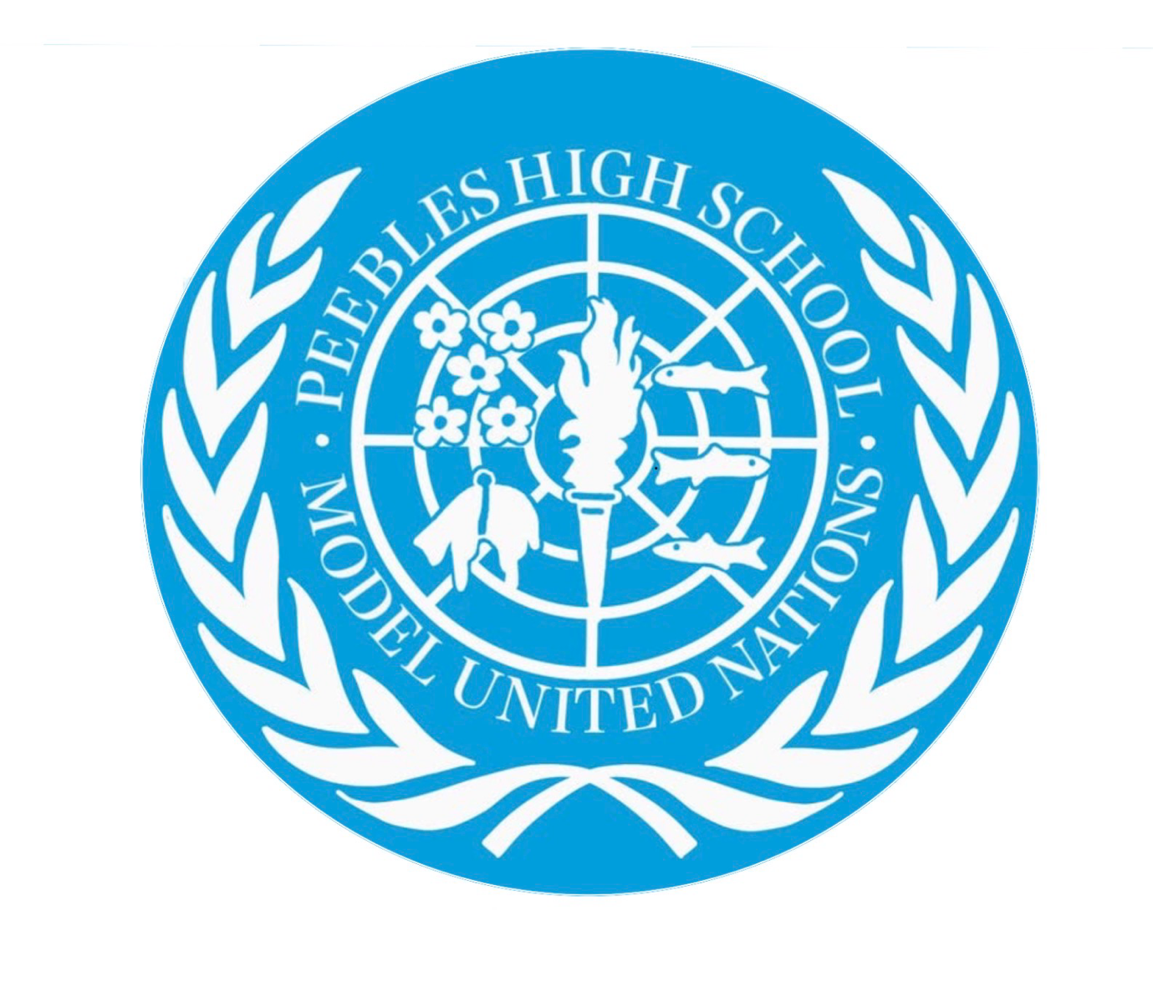

Arctic council topic 1: Arctic Wildlife and Indigenous Rights

Chairs: Dawa Murray and Innis Reilly

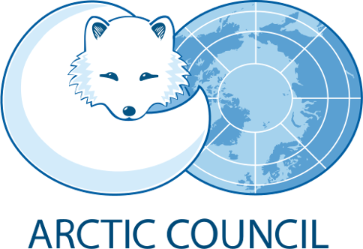
Background
The Arctic is one of the world's most environmentally significant and vulnerable regions, encompassing the Arctic Ocean and the northern territories of Canada, Denmark (through Greenland), Finland, Iceland, Norway, Russia, Sweden and the United States (through Alaska). Despite its extreme climate, the region supports a diverse range of wildlife, including polar bears, Arctic foxes, walruses, narwhals, seals, reindeer and many migratory bird species.
However, the Arctic is experiencing increasingly significant environmental changes. Rising temperatures are causing sea ice to decline, permafrost to thaw and established ecosystems to change. These developments threaten species that depend upon stable ice conditions for hunting, breeding and migration. Polar bears, for example, rely heavily on sea ice to hunt seals, while walruses use ice as resting platforms between feeding periods.
Alongside climate change, growing commercial activity is creating additional challenges. The reduction of sea ice has made previously inaccessible areas more available for shipping, fishing, tourism and natural resource extraction. Oil and gas exploration, mining and increased maritime traffic introduce risks including pollution, habitat destruction and disturbance to wildlife.
The Arctic is also home to approximately four million people, around 500,000 of whom belong to Indigenous communities. These include the Inuit, Sámi, Gwich'in and Aleut peoples, alongside many Indigenous communities across northern Russia. For many, wildlife and the natural environment are fundamental to traditional livelihoods, cultural identity and food security. Hunting, fishing and reindeer herding have been maintained across generations, often relying upon detailed knowledge of local ecosystems.
Consequently, environmental protection cannot be separated from Indigenous rights. Measures intended to conserve wildlife, such as restrictions on hunting or the creation of protected areas, can also affect communities whose traditional livelihoods depend upon access to these environments. The main issue is creating effective conservation measures without undermining the rights, traditions and economic security of Arctic Indigenous peoples.

The Arctic Council's Role
The Arctic Council was formed in 1996 through the Ottawa Declaration. It provides a framework for cooperation between the eight Arctic States, with particular emphasis on environmental protection and sustainable development. Unlike the United Nations, the Council is not an organisation with independent enforcement powers. Its decisions are reached through consensus between its eight member states.
An important feature of the Council is the participation of six Indigenous organisations, which hold Permanent Participant status. These include the Inuit Circumpolar Council, Saami Council, Arctic Athabaskan Council, Gwich'in Council International, Aleut International Association and Russian Association of Indigenous Peoples of the North. They have full consultation rights in Council negotiations and decisions, allowing Indigenous representatives to contribute directly to discussions affecting their communities.
The Council operates through six working groups, the most relevant to this debate being
- Conservation of Arctic Flora and Fauna (CAFF) - responsible for monitoring and supporting the conservation of Arctic biodiversity and wildlife habitats.
- Arctic Monitoring and Assessment Programme (AMAP) - monitors and assesses environmental pollution and climate change.
- Protection of the Arctic Marine Environment (PAME) - focuses on marine conservation, shipping and pollution.
- Sustainable Development Working Group (SDWG) - considers the social, economic and environmental wellbeing of Arctic communities.
The Council has also made multiple legally binding international agreements, including the 2011 Agreement on Cooperation on Aeronautical and Maritime Search and Rescue in the Arctic and the 2013 Agreement on Cooperation on Marine Oil Pollution Preparedness and Response in the Arctic.
Nevertheless, the Council faces limitations. It cannot independently enforce environmental regulations or compel member states to implement its recommendations. Furthermore, geopolitical tensions, particularly following Russia's invasion of Ukraine in 2022, have complicated regional cooperation. Although Working Group meetings gradually resumed virtually in 2024, political divisions remain an obstacle to cooperation.

Environmental Situation

The decline of Arctic wildlife is driven by several interconnected environmental and economic pressures. Although climate change is a major long-term threat, increasing human activity is placing additional pressure on already vulnerable ecosystems.
Climate Change and Habitat Loss
The Arctic is warming considerably faster than the global average, resulting in the continued reduction of sea ice and changes to essential ecosystems. The 2025 Arctic Report Card recorded the highest Arctic annual temperatures since records began in 1900. Species such as polar bears, seals and walruses depend upon sea ice for feeding, reproduction and migration.
Thawing permafrost also threatens Arctic ecosystems, changing landscapes and releasing previously trapped greenhouse gases. Changes in temperature and seasonal patterns additionally affect vegetation, migration routes and food availability for species such as caribou and reindeer.
Commercial Development and Pollution
The reduction of sea ice has created opportunities for increased commercial activity throughout the region. Shipping routes, particularly the Northern Sea Route along Russia's northern coastline and the Northwest Passage through Canada, are becoming increasingly accessible.
However, increased shipping creates risks including oil spills, underwater noise pollution and collisions with marine wildlife. Similarly, oil and gas exploration and mining can disturb breeding grounds, damage habitats and introduce pollutants into fragile ecosystems.
Commercial fishing presents another concern. In 2018, ten parties, including the eight Arctic States, China, Japan, South Korea and the European Union, signed the Agreement to Prevent Unregulated High Seas Fisheries in the Central Arctic Ocean. This agreement entered into force in 2021 and set up an initial 16-year prohibition on commercial fishing in the high seas portion of the Central Arctic Ocean, allowing time for scientific research into its marine ecosystems.
Indigenous Rights and Traditional Livelihoods
Environmental changes are having significant consequences for Arctic Indigenous communities. Traditional activities such as reindeer herding, hunting and fishing depend upon stable ecosystems and the continued availability of wildlife. Changing migration patterns, melting ice and declining animal populations make these activities increasingly difficult.
There are also concerns surrounding commercial development. Mining, oil exploration and infrastructure projects can affect traditional hunting grounds, grazing areas and access to natural resources. In some circumstances, Indigenous communities argue that governments and private companies have prioritised economic development without adequately consulting those affected.
The United Nations Declaration on the Rights of Indigenous Peoples (UNDRIP), adopted in 2007, establishes important principles concerning Indigenous self-determination, land rights and cultural preservation. Articles 19 and 32 are particularly relevant, addressing consultation and free, prior and informed consent before decisions or development projects affecting Indigenous peoples are approved. However, UNDRIP is a declaration rather than a legally binding international treaty.

Key Positions of Major Actors
Canada - Supports international cooperation on Arctic environmental protection while supporting an interest in the sustainable development of its northern territories. Indigenous rights, particularly those of Inuit and First Nations communities, are important considerations in Canadian Arctic policy.
Kingdom of Denmark (Greenland) - Denmark's Arctic interests are closely connected to Greenland, which has extensive autonomy and a significant Indigenous Inuit population. Greenland must balance environmental protection and traditional livelihoods with economic development, particularly through fishing and mineral resources.
Finland - Has significant interests in protecting northern ecosystems and the livelihoods of Sámi communities, particularly traditional reindeer herding. Mining and forestry developments can create competing pressures.
Iceland - Has strong interests in sustainable fisheries, marine conservation and maintaining the economic importance of its fishing industry. It is also concerned with the environmental consequences of changing Arctic conditions.
Norway - Balances environmental protection with its significant fishing, maritime and offshore energy industries. The protection of marine ecosystems and Sámi rights are important domestic considerations.
Russia - Has the largest Arctic coastline and has significant economic interests in the region, particularly through shipping, oil, gas and mineral extraction. It also has numerous Indigenous communities across its northern territories. Its relationship with other Arctic States continues to complicate international cooperation.
Sweden - Has significant interests in protecting Arctic biodiversity and Sámi communities, particularly in relation to reindeer herding and traditional land use. Mining and forestry developments have created disagreements concerning land rights and environmental protection.
United States - Has considerable Arctic interests through Alaska, including energy development, fishing and maritime activity. It also recognises the importance of protecting Alaskan Indigenous communities and wildlife, although balancing conservation with economic development remains a significant consideration.
Arctic Indigenous Organisations - The six Permanent Participants emphasise meaningful participation in decision-making, protection of traditional territories, preservation of cultural practices and recognition of traditional ecological knowledge.

